
New World Industries Inc.

RF-550-1 thru -8EF Wireless Controller
The RF-550 wireless controller is a compact unit with two parts. One part is the base unit and the other piece is the keyfob actuator. Base units are available with 1 thru 8,VDC momentary or optional latching outputs that can be used to trigger the I/O’s on all of NWI’s standard line of controllers or other devices. The keyfob or 8 button transmitter is used to send a corresponding signal to the base unit to act as a remote switching device.
These units can be ordered in a variety of configurations. With the double-pull option, the user can activate up to 8 functions that turn on a pump/motor coil simultaneously. Also available is 1 latching circuit. This can act as an on/off switch to a component.
Depending on the number of remotely activated outputs, that number is reflected in the dash # suffix of the model, i.e. a RF-550-5 would be a 5 output base unit with a 5-button keyfob. If a double-pull is desired on 2 of 5 outputs the P/N would be RF-500-5DP2. When the latching circuit is need on the above the P/N would be RF-500-5DP3L1. See wiring instructions to connect the receiver to the desired function using the color-coded wires.

Set-up and Operation
All RF-550 controllers come factory un-programmed. That means matching the base unit to the keyfob/8 button transmitter is done by the end-user. This gives a matched (1 of 16 million combinations @ 418MHz) interface between the keyfob and base unit. See Figure 1 for keyfob button assignments. (8 buttons transmitter are numbered)

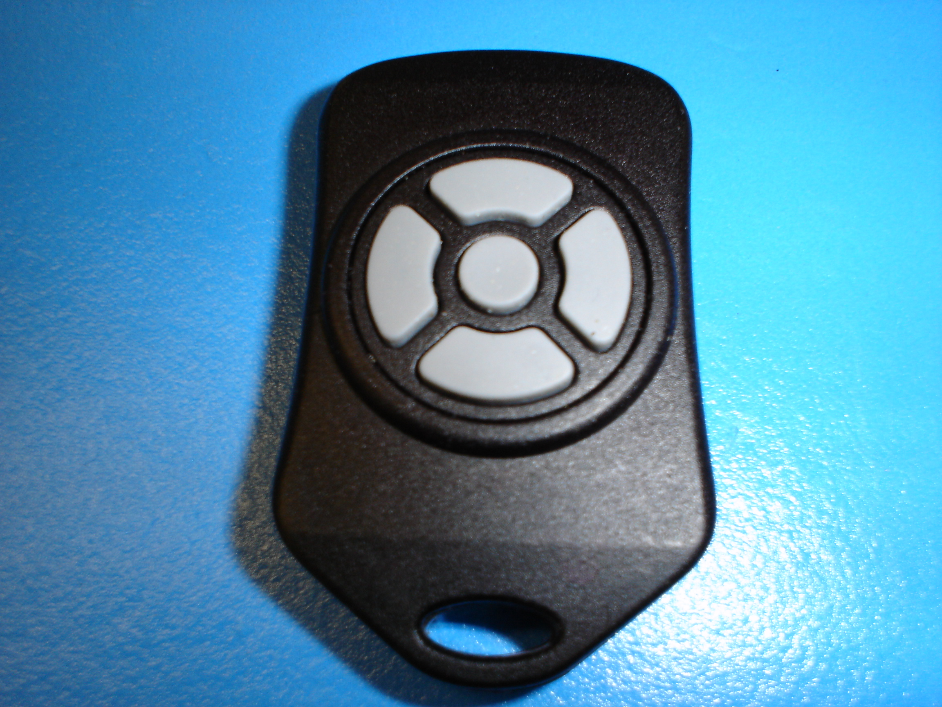
S4
S3
S5
S1
S2

Fig. 1 Keyfob Button Assignments
The RF-550 comes in different configurations. Shown above is the 5 output example (i.e. RF-550-5). This is the maximum controlled output using a keyfob. As the number of available outputs decrease so will the amount of buttons on the keyfob. The button # assignments are always in the same place. They decrease in this order:

- 4 Button keyfob will be minus S5 button/ RF-550-4
- 3 Button keyfob will be minus S1 and S3/ RF-550-3
- 2 Button keyfob will be minus S1, S3 and S5/ RF-550-2
- 1 Button keyfob will be minus S1, S2, S3 and S4/ RF-550-1

Fig. 2 is the receiver or base unit. This picture shows the terminal designations and other functions.
Antenna

Receiver
Programming
Red LED

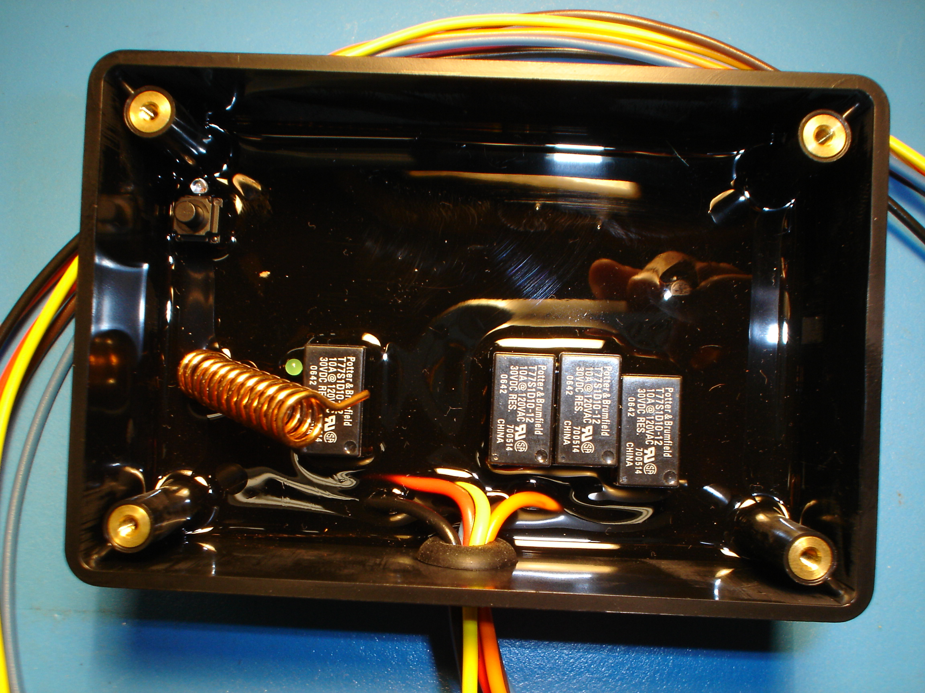
PWR
Grn LED
Learn
Address
Button

Fig. 2 Receiver Connection diagram and layout

Set-up of Keyfob/8 Button Transmitter to Receiver Address

The next step to the RF-550 installation is to create a 1 in 16 million address between the keyfob and the base unit.

Please follow these steps:

- Power-up the RF-550 receiver. (Green LED on)
- On the backside of the keyfob/8 Button depress the “ADD” button using a paperclip (if working properly a blue light in the window will blink).
- Flip keyfob over and push each button individually to send address to the receiver. The blue light will automatically turn off after 18 seconds from the time you first push the buttons. Now the keyfob has acquired its unique address.
- Go to the receiver box and push the black (learn) button. The red LED will begin to flash.
- Again, push button #1 on the keyfob/8 Button to save that unique address to the receiver. Push the black button once again on the receiver box and the address programming is complete.

Your RF-550 is now ready to use.

Battery Replacement
The keyfob/8 Button uses a standard CR2032 lithium button cell battery. In normal use it will provide 1 to 2 years of operation. To replace the battery (keyfob), gently pry apart the 2 halves. Remove the battery by sliding it out from underneath the retainer. Observe the battery polarity when replacing. Replacing the 8 Button battery requires gently prying the battery cover open.

Other Considerations
Only one transmitter at a time can be activated within a reception area. Only one carrier of a particular frequency may occupy the same airspace at a given time. This means that if two transmitters are activated in the same area at the same time the signals will interfere and the decoder on the receiver will not see a valid transmission and the RF-500 will not function. If the range of the transmitter needs to be increased, contact your supplier and ask about antenna options of up to 1000ft.
Also New World Industries Inc has no control over the intended usage of this product. Because of that New World Industries offers no written or expressed liability as to how this product is used. NWI recommends that these units are intended for OFF ROAD USE ONLY
For further technical assistance please contact New World Industries Inc.

Copyright, New World Industries Inc., 2006

TROUBLE SHOOTING

Follow these steps:
- Make sure the green LED is lit when the receiver power is turns on. If the LED is not on, check your power supply to the receiver.
- With the receiver powered up, make sure the red LED comes on when the buttons are depressed on the keyfob. If the red LED does not come on the receiver is not getting a signal from the transmitter. If the battery in the transmitter is more than 2 years old check battery voltage with a meter or replace battery.
- After completing the above steps and the unit still will not function, follow the procedure, Set-up of Keyfob to Receiver Address.
- If the unit still will not operate. Check connections to the component that the unit is trying to accurate using a voltmeter.

